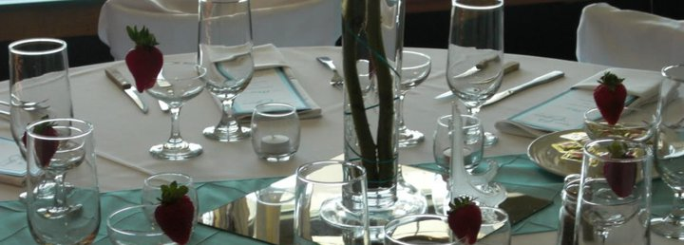
Heritage Glen Golf Club
Buffet Banquet Menu 2022
Entrees
Prices are per person and subject to change

Beef Filet of Sirloin $28.95 *****
Tender filet of sirloin grilled to perfection
Carved Beef Tenderloin $30.95*****
Slow roasted beef tenderloin carved and served with horseradish sauce
Prime Rib Carving Station $28.95*****
Slow roasted prime rib carved and served with horseradish sauce
Braised Beef $22.95*****
Tender beef slowly cooked with carrots, celery, and onion
Fresh Fish $20.95****
Wild caught Salmon croquettes topped with fresh herbs and a béchamel sauce
Gourmet Stuffed Chicken Breast $20.95****
Choice of Cordon Blue-ham and Swiss filling,
Florentine-spinach, artichokes, parsley, and cream cheese filling
Grilled Chicken Breast $15.95*
Marinated grilled chicken breast
Grilled Chicken Specialty $16.95***
Marsala - Grilled chicken breast topped with a homemade Marsala wine sauce with sautéed mushrooms
Piccata - Pan fried chicken topped with a white wine and a brown butter caper sauce
Teriyaki - Grilled chicken breast with teriyaki sauce and grilled pineapple
Breaded Chicken Breast $17.95***
Monterey Chicken – Topped with sautéed mushrooms and Monterey Jack cheese
Chicken Parmesan – Topped with marinara sauce and mozzarella cheese
Lasagna Vegetarian $15.95, with meat $16.95*
Layered noodles with vegetables or meat, mozzarella cheese
Pasta Bar $16.95**
Penne pasta served with grilled chicken strips and
Your choice of three sauces: Alfredo, Pesto, Creamy Pesto, Marinara or Meaty Marinara
Portabella Ravioli $17.95***
Mushroom stuffed ravioli with our signature Creamy Pesto sauce
Pork $23.95***
Roasted Pork Loin - Tender pork loin with a seared hickory crust
Stuffed Pork Loin – Pork Loin stuffed with apples, cherries, red onion, fresh sage and garlic
BBQ Ribs – Smoked tender baby back ribs rubbed with our special dry rub and smoked for over applewood

Select One Vegetable, One Starch and One Salad
Rolls & Butter included
-Each Additional Side Dish $3 extra per person-
Vegetables
Bean and Carrot Medley, Glazed Carrots, Green Bean Casserole, Green Bean Almandine, Steamed Green Beans, California Blend Vegetables, Summer Squash and Zucchini, Buttered Sweet Corn or Coleslaw
Starch
Potatoes: Herb Roasted Redskins, Smashed Redskins, Baked, Au Gratin, Scalloped, Mashed with Home-style gravy, Duchess Potatoes, Potatoes Anna. Other Options: Heritage Glen’s Signature Potato Salad,
Wild Rice Pilaf, Baked Macaroni and Cheese, Stuffing and risotto
Salads
Caesar: Romaine lettuce, tomato, red onion, parmesan, and croutons tossed with Caesar dressing
Greek: Romaine lettuce, red onion, tomato, black olives, pepperoncini peppers, and feta cheese
tossed with Balsamic Vinaigrette
House: Mixed field greens, red onion, tomato, cucumber, croutons, cheese, and 2 dressing choices
Mediterranean: Mixed field greens, thin red onions, grape tomatoes, dried cherries, cranberries, and candied almonds all tossed in a raspberry vinaigrette and topped with parmesan cheese
Spinach: Fresh baby spinach with feta cheese, dried cherries, red onion, tomato and tossed with Balsamic Vinaigrette

Our professional staff is more than willing to customize your menu and welcomes your requests
For the option of a second Entrée’ - per person

Desserts $5.95
Ask about our assorted cakes, pies, and other options

For the option of a second entrée’
Add $5.00 per person
** Add $6.00
*** Add $8.00
**** Add $10.00
***** Add $14.00

